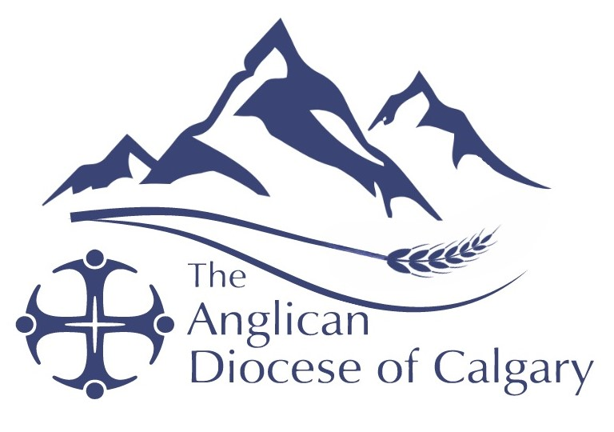

PRAYER CALENDAR
Second Quarter: April – June 2025

Your prayers each week are also asked for:
The Most Rev. Anne Germond, Acting Primate of The Anglican Church of Canada;
The Most Rev. Gregory Kerr-Wilson, Metropolitan of the Ecclesiastical Province of
The Northern Lights, and Archbishop of the Anglican Diocese of Calgary;
The Rt. Rev. Leopold Friday, Bishop of our Companion Diocese of the Windward Islands;
and Leaders of your own Parish.

 | In Our Diocese | Companion Diocese of the Windward Islands
April 6, 2025 | St. George, Calgary  The Rev. Dr. Chris Nojonen  The Refugee Committee | Cathedral Church of St. George (Parish of St. George & St. Andrew) with Transfiguration, The Ascension and Holy Redeemer  The Very Rev. Samuel Nichols  Diocesan Officers: Chancellor Stanley John, Grenville John, Idris Baptiste, Clifton Nedd and Dionne John
April 13, 2025 | St. James, Calgary  The Rev. Dr. Dane Neufeld  The Rev. Dr. Carmen Maier  The Rev. Deacon David Ginther  National House of Bishops | Holy Trinity, Georgetown with St. John, Holy Name, St. Peter, St. Luke, and Byera Chapel, on St. Vincent  The Ven. Junior Ballantyne
April 20, 2025 | All Saints, Cochrane  The Rev. Fariborz Khandani  The Rev. Deacon Ruth-Anne Marley  The Rev. Deacon Elizabeth Short  Children and Young Families | St. James, Layou with St. Mary, Buccament on St. Vincent  The Rev. Canon Ashton Francis  Principals at Secondary Schools  - Bishop College, Kingstown  - Bequia Anglican Community High School  - Bishop’s College, Carriacou  (carry-eye-coo)  - Anglican High School, Grenada  - St. Andrew’s Secondary School
April 27, 2025 | St. Andrew, Gleichen  The Rev. Brad Everett  St. Michael & All Angels, Strathmore  The Rev. Malcolm Kern  Missional Coaches | St. Mary, Bequia (bek-way) with Holy Cross, Paget Farm, Mustique; St. Michael, Canouan; and St. Matthias, Union Island  The Ven. J. Everton Weekes  The Rev. Frank Garraway
May 4, 2025 | Christ Church, Calgary  The Rev. Brandon Witwer  The Rev. Adam Bedford  The Rev. C. McPhail Jones (Hon.)  The Very Rev. Robert T. Pynn (Hon.)  Administration & Finance Committee | St. Andrew with Holy Innocents, St. Giles and St. Michael  The Ven. Michael Marshall  St. John with St. Mark and St. Matthew  The Rev. Coleridge Brooker  Christ-the-King with St. Francis, on Grenada  The Rev. Dr. Thomas Mayers
May 11, 2025 | St. Michael, Canmore  The Rev. Jesse Holland  The Rev. Deacon Sean Krausert  The Rev. Canon Dr. Richard LeSueur (Hon.)  Diocesan Council | Holy Trinity, Castries with St. Mary, La Caye, on St. Lucia  The Ven. Christian Glasgow
May 18, 2025 | Church of the Good Shepherd, Calgary  The Rev. Cpt. Derwyn Costinak  The Rev. Margaret Hogarth  Indigenous Ministries | St. Paul, Calliaqua (kal-ee-a-kwa) with St. John, Belair  The Rev. Canon Ashton Francis  Mothers’ Union Diocesan President Mrs. Hermione St. Bernard
May 25, 2025 | Holy Nativity, Calgary  The Ven. Brian Vickers  The Rev. Deacon Bob Mummery  Clergy Conference (May 27 to 29) | St. Philip, Mesopotamia with St. Matthias and St. Joseph, on St. Vincent  The Rev. Canon Ashton Francis
June 1, 2025 | St. Augustine, Calgary  The Wardens  Property Committee | St. Matthew, Biabou (bee-a-bou) with St. Sylvan, Stubbs and St. Mark, Greggs, on St. Vincent  The Rev. Deacon Kenwick Lewis
June 8, 2025 | St. Peter, Okotoks  The Rev. Dr. Norbert Haukenfrers  Vocational & Transitional Deacons | St. Patrick, Barrouallie (barrel-ee) with St. David, Our Lady of Perpetual Succour, All Saints, and Mary Magdalene, on St. Vincent  The Rev. Alison Samuel
June 15, 2025 | St. Theodore, Taber  The Wardens  Education for Ministry (EfM) | St. David and St. Paul on Grenada  The Rev. Fr. Edward Mark
June 22, 2025 | St. Luke, Red Deer  The Ven. Noel Wygiera  The Rev. Deacon Tracey Stagg  General Synod 2025 – June 22 - 29 | Grace Church, Riviere Doree with St. Paul and Christ-the-King on St. Lucia  The Rev. Eleanor Glasgow
June 29, 2025 | St. Francis of Assisi, Airdrie  The Rev. Daniel Joseph  The Rev. ‘Daisi Oke  The Rev. Deacon Jennifer Ingram  The Rev. Joan Schellenberger (Hon.)  Calgary School of Discipleship | St. George with St. Vincent, St. Peter, St. Luke and St. Alban  The Ven. Michael Marshall  St. Patrick with St. Mary and St. Francis, on Grenada

